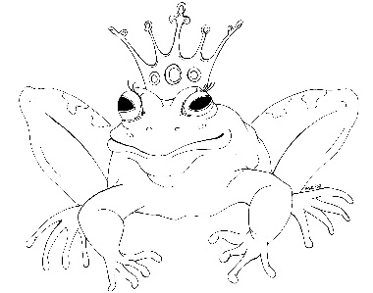
From the Desk of E.D. Baker
The Salamander Spell – Discussion Questions

​
​

​
Why didn’t King Aldrid believe in the curse before it changed his wife?

​
After the curse changed Olivene from a good witch to a nasty one, what did she do to her husband and children?

​
What do you think happened when Olivene was a chicken that she didn’t want to talk about later?

​
What do you think Olivene would have done if she’d found Pippa in Grassina’s bed chamber?

​
What was Olivene doing during the thunderstorm?

​
Why did Chartreuse say such horrible things to Grassina after their encounter with the ghosts and the shadow beast?

​
What do you think would have happened if Grassina hadn’t run away from home?

​
Grassina encountered three different kinds of dangerous creatures in the enchanted forest. Which do you think was the worse?

​
Why do you think Olivene threw Aldrid’s possessions down the dungeon stairs?

​
If you had small magic like Haywood, what other insects, birds or animals would you have called upon to help Grassina fight the manticore?

