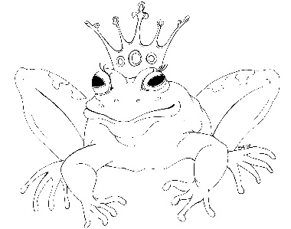
From the Desk of E.D. Baker
The Dragon Princess – Discussion Questions

Millie tried all sorts of things to keep from turning into a dragon. What else could she have tried?

Why did Millie reject Prince Leopold? Prince Atworth?

Why did Millie and her parents travel to Upper Montevista for her birthday?

Who was unable to attend Millie’s party because it was moved to Upper Montevista?

Why did Queen Frazella want Millie to have her birthday party in Upper Montevista?

Describe how someone tricked you into doing something that you didn’t want to do. How did it make you feel?

Why was Mudine looking for Li’l?

Why did Simon-Leo want to go with Millie, Zoe and Francis?

Why was the water nymph mad at Millie and Francis?

How is a dragon more powerful than a knucker?

What dangers did Mille and her companions face as they climbed the mountain?

Choose a room in the ice palace and describe it using all five senses.

Aside from the magic carpet, what magical items do you think Azuria took with her when she fled the castle?

What qualities do you think a witch must have to be called the Blue Witch?

What do you think happened when Francis, Zoe and Millie returned to the castle in Upper Montevista?

