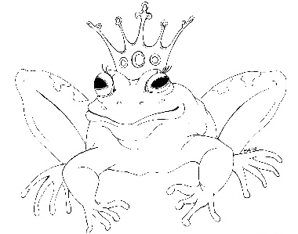
From the Desk of E.D. Baker

Fairy Tale Matchmaker Discussion Questions

What kind of relationship did Cory have with her mother?

Why wasn't Cory happy as a tooth fairy?

How do you think Walker really felt about Cory?

How would you describe Blue's personality?

Why did Cory's mother side with the Tooth Fairy Guild rather than Cory?

Why can't Cory use her powers to find her own true love?

Why were Cory's abilities unclear when she was in Junior Fey School?

Who else do you think would visit Suzy's store?

What other jobs might Cory find in the Fey Express?

Why didn't Cory's mother want to tell her about Lionel?

Why were the putti so happy to see Cory?

